Name: Anu Aniyammal.S

**Date: 17/12/2024**

* create pods for the images u have pushed to your docker hub.

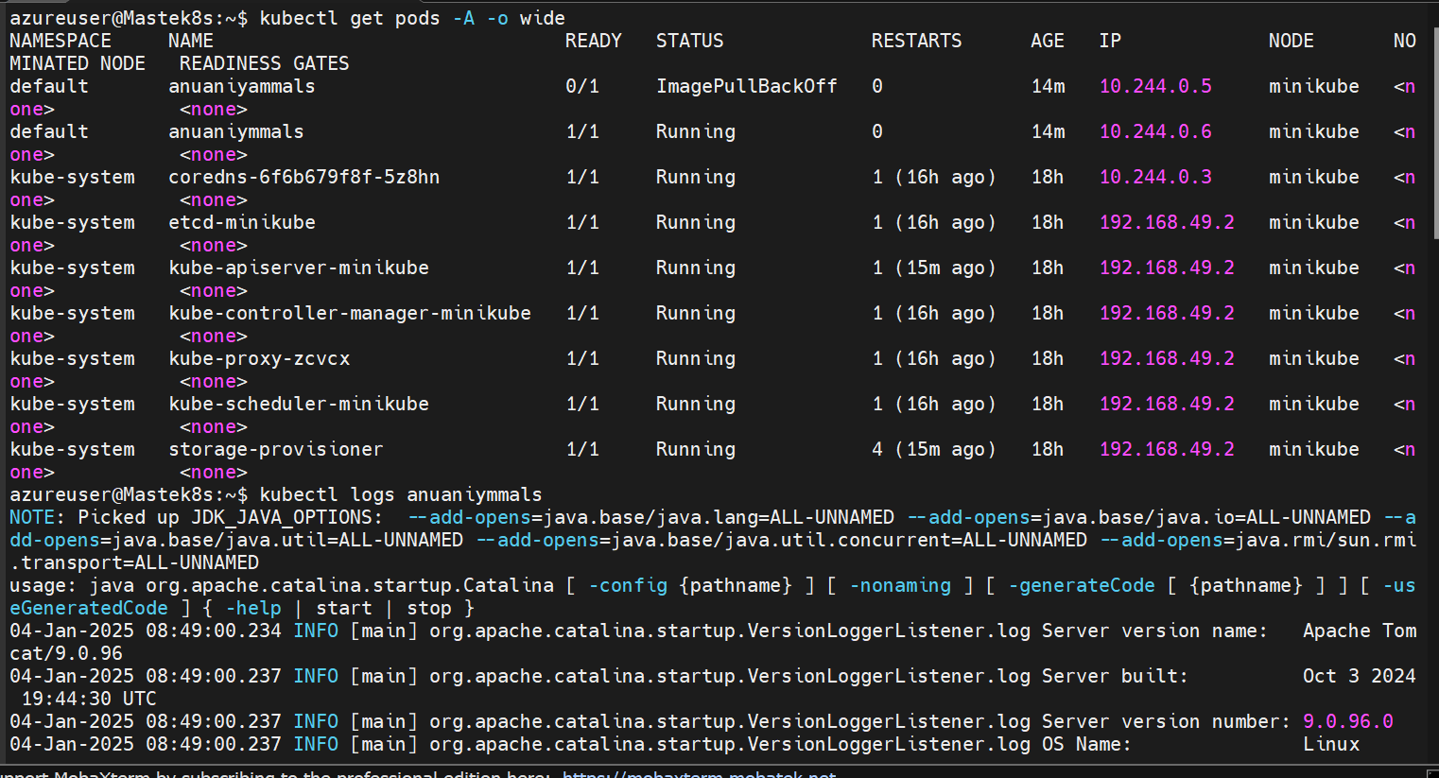

Check end points and ports exposed -without this two its tough to access a ocntainer

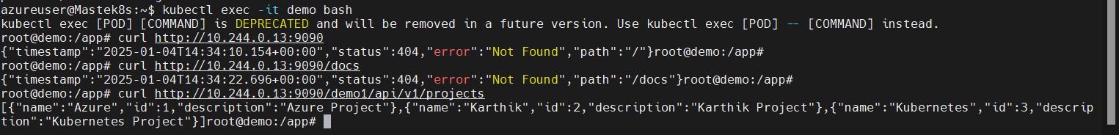

**Date: 18/12/2024- Controllers**

Created a demo deployment controller with specified ports and created a replica set demo-5f4 and ready indicates it has replica set of 1 here.

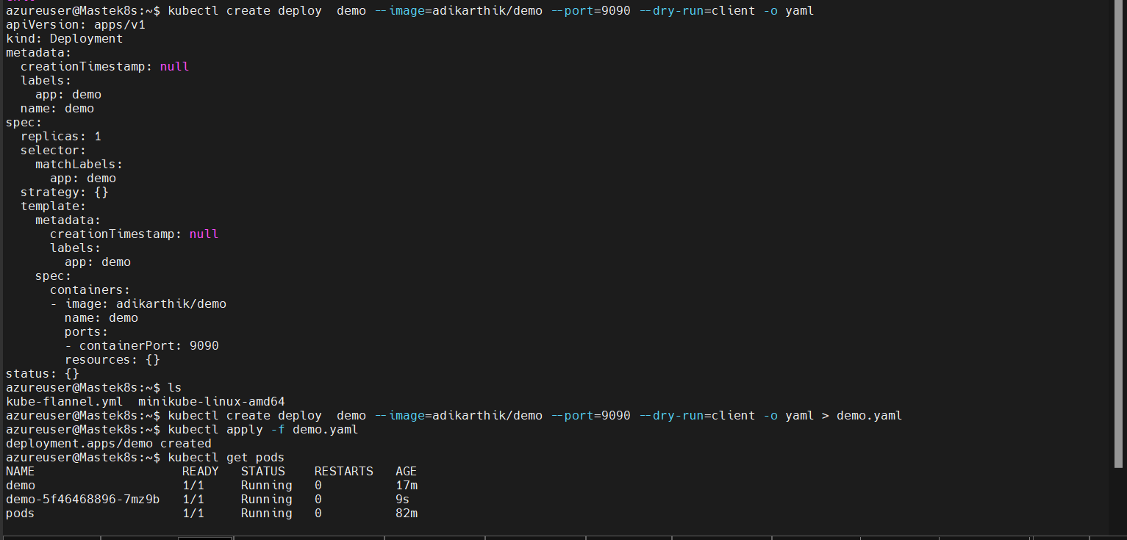

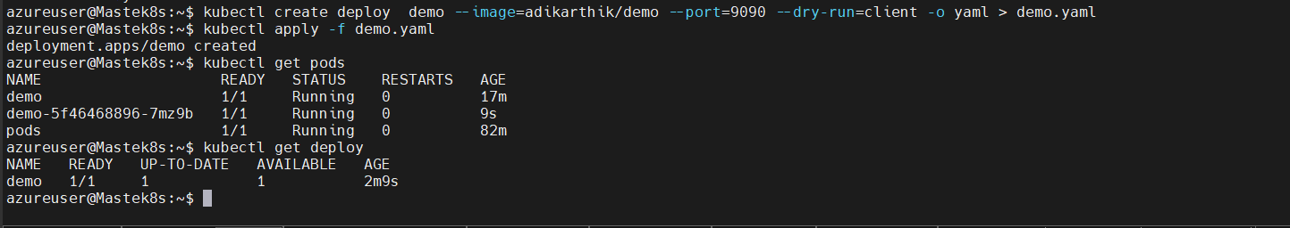

Unique replica set also created.



Daemonset -default without creation



Job controller

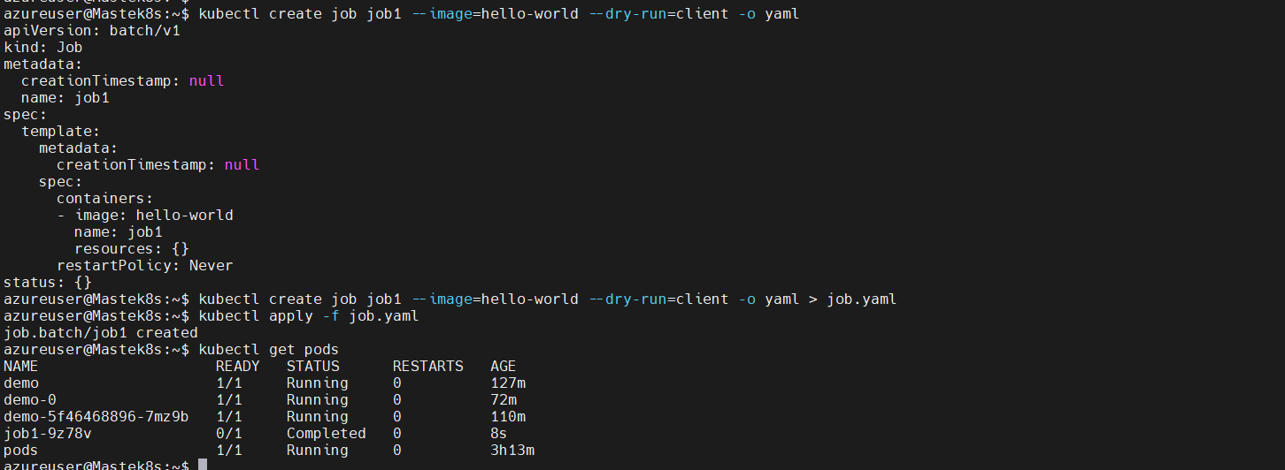

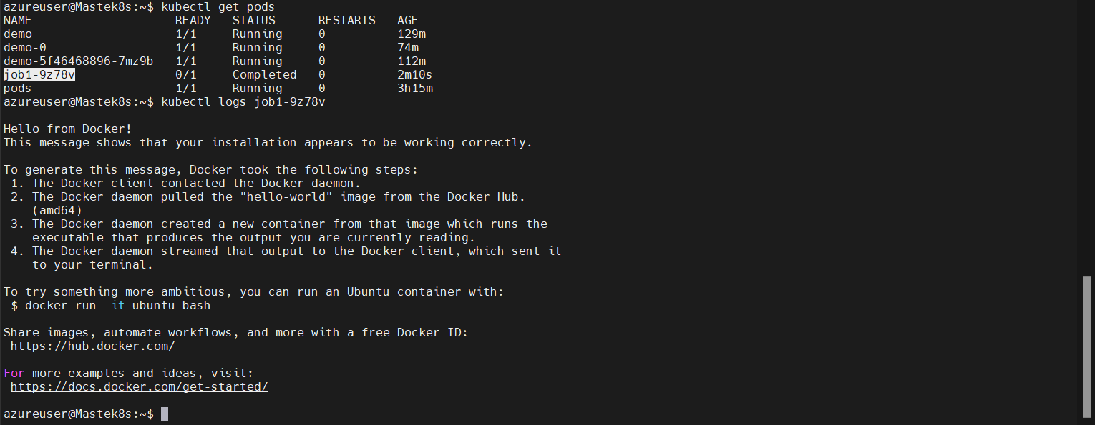

task: create a cronjob to print date at every 5 mins.

apiVersion: batch/v1

kind: CronJob

metadata:

name: print-date

spec:

schedule: "*/5 * * * *"

successfulJobsHistoryLimit: 10

failedJobsHistoryLimit: 1

jobTemplate:

spec:

ttlSecondsAfterFinished: 3600 # Keep pods for 1 hour after completion

template:

spec:

containers:

- name: print-date

image: busybox

command:

- /bin/sh

- -c

- "date; echo 'Printed by Kubernetes CronJob'"

restartPolicy: OnFailure

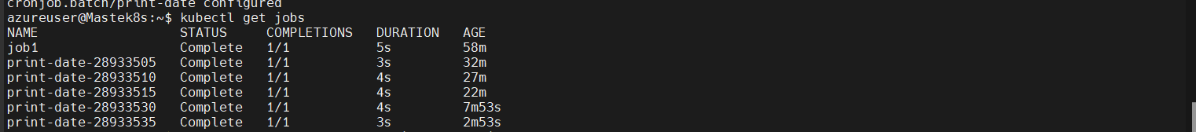



**Date: 19/12/2024 - Services**

**Cluster IP**

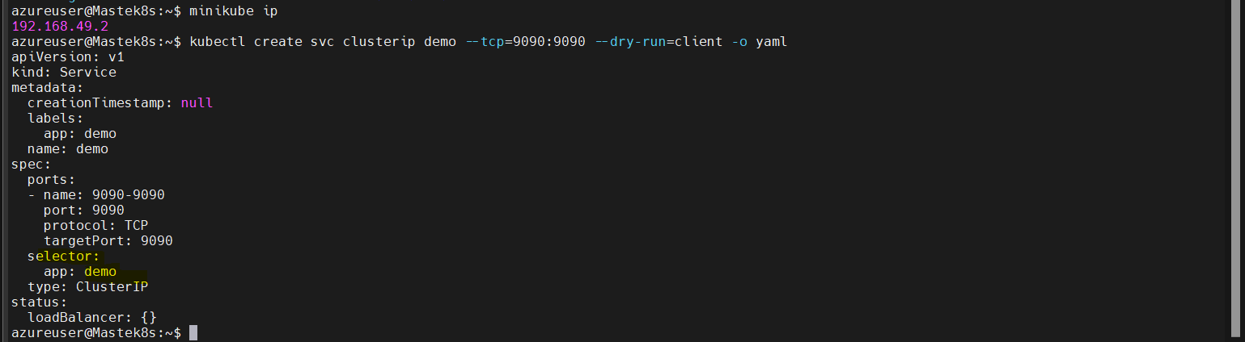



Until we match the selector with a pod of any controller type u will not get response.

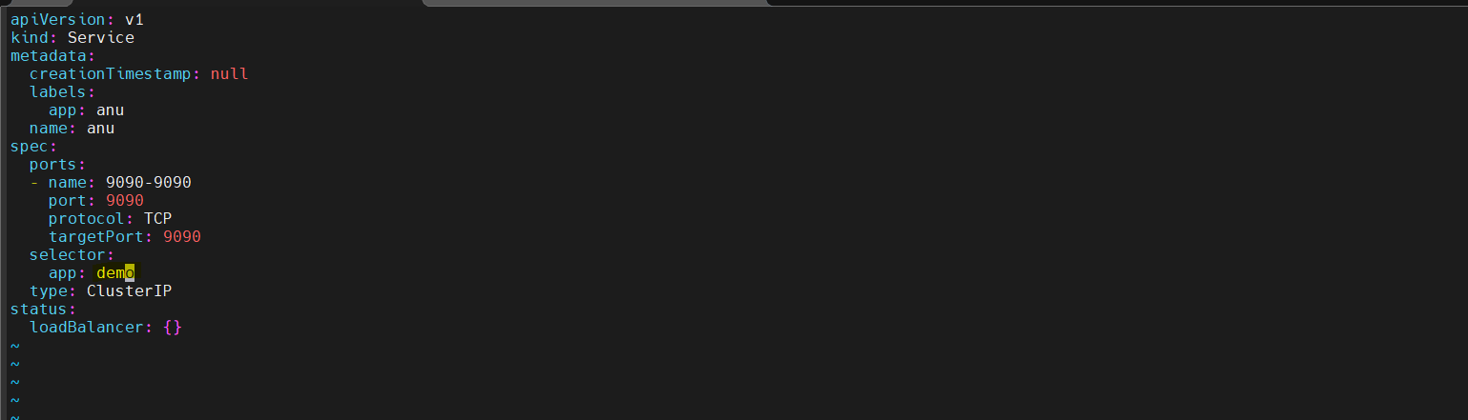



Node port service

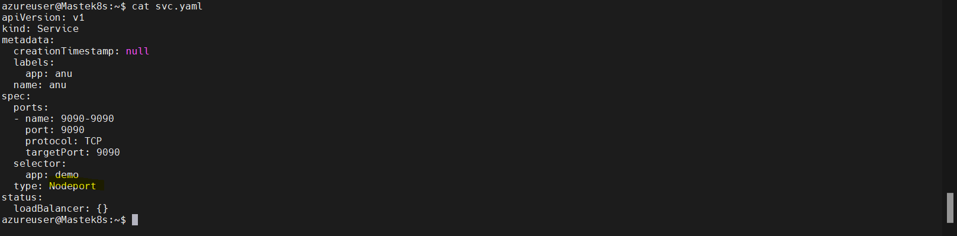

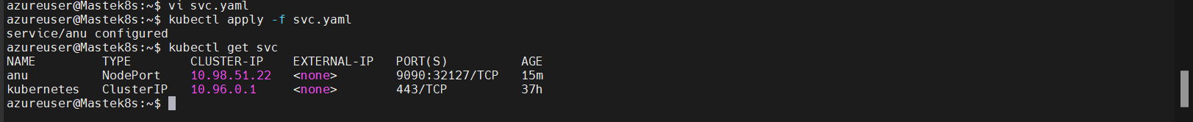



**Date: 20/12/2024-ingress**

* **creating ingress**

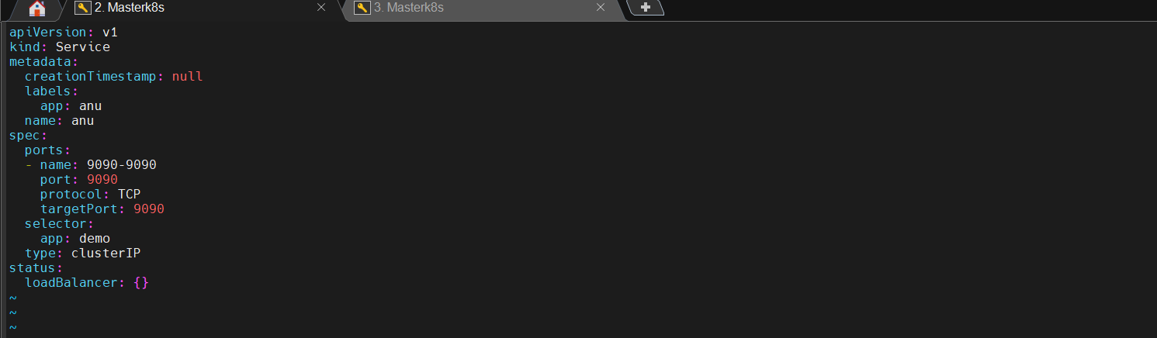



* helm installation.

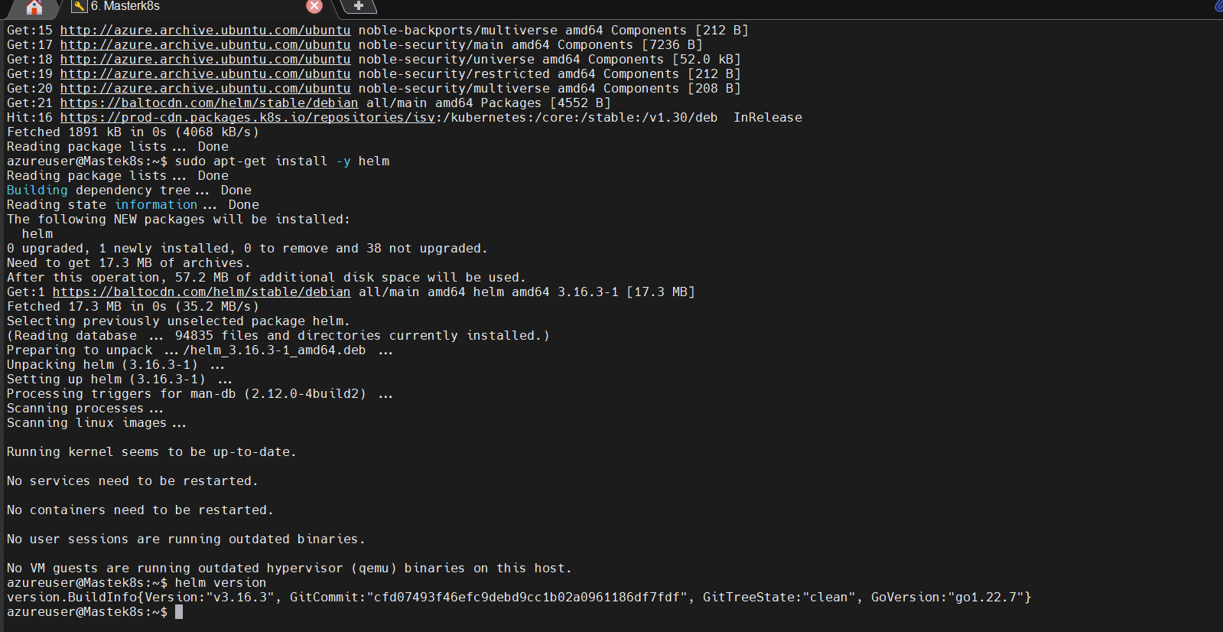

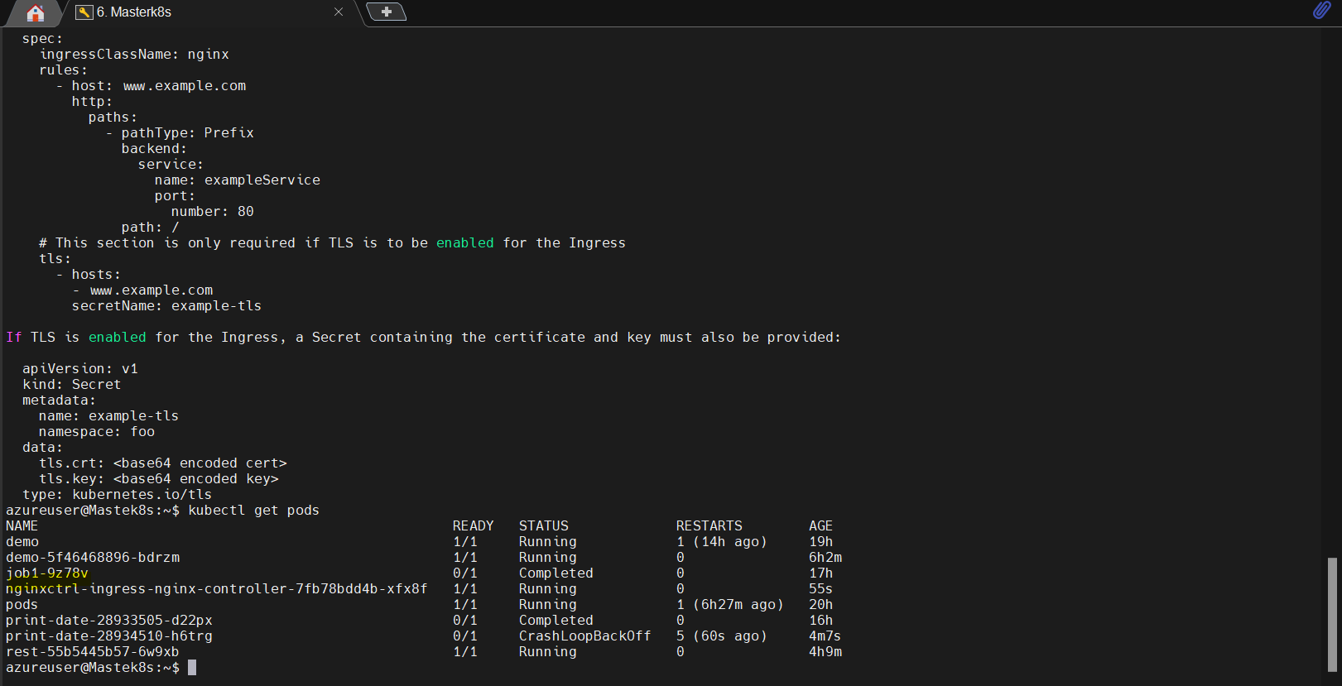

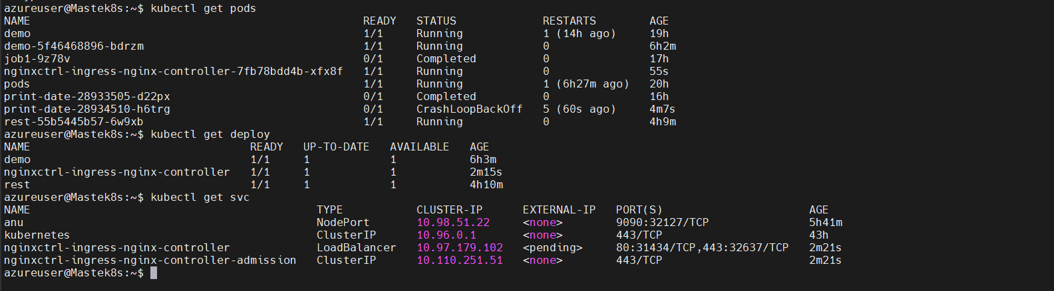

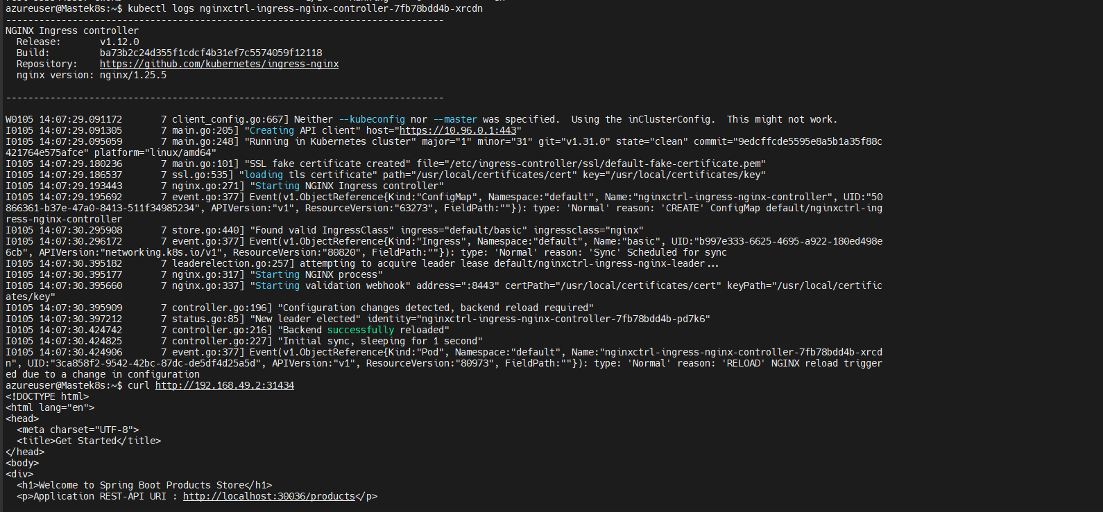

* Yaml file for ingress basic (with two services) we can mention end points in path

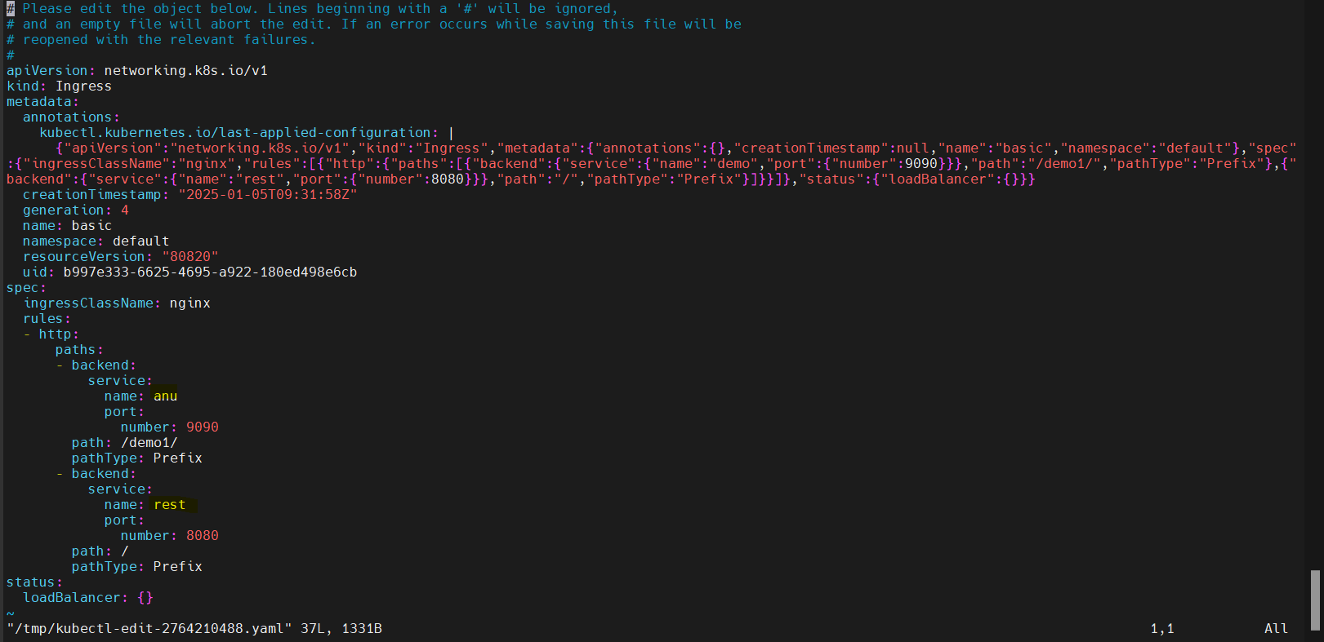

* Both (rest and anu) services were reachable.

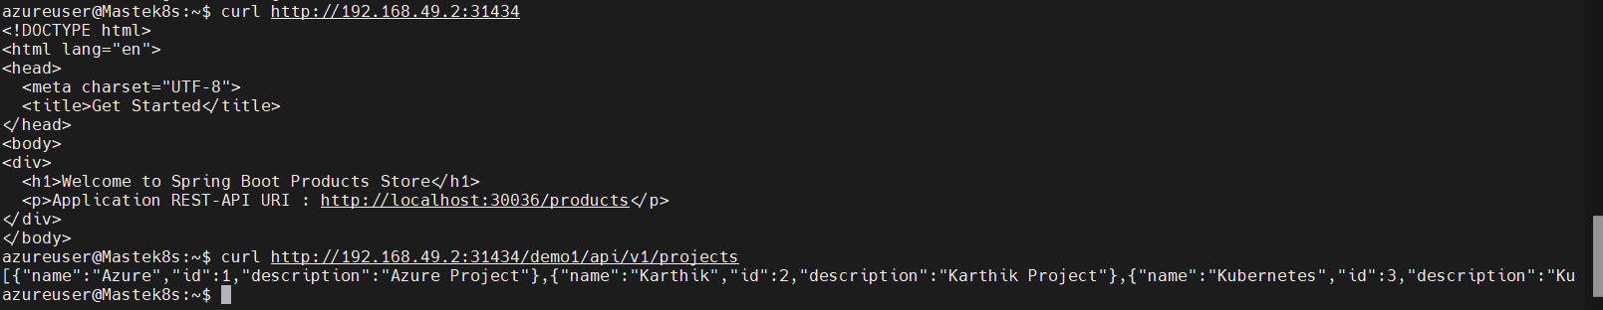

**Date: 21/12/2024: Aks demo**

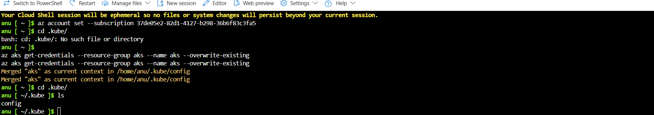

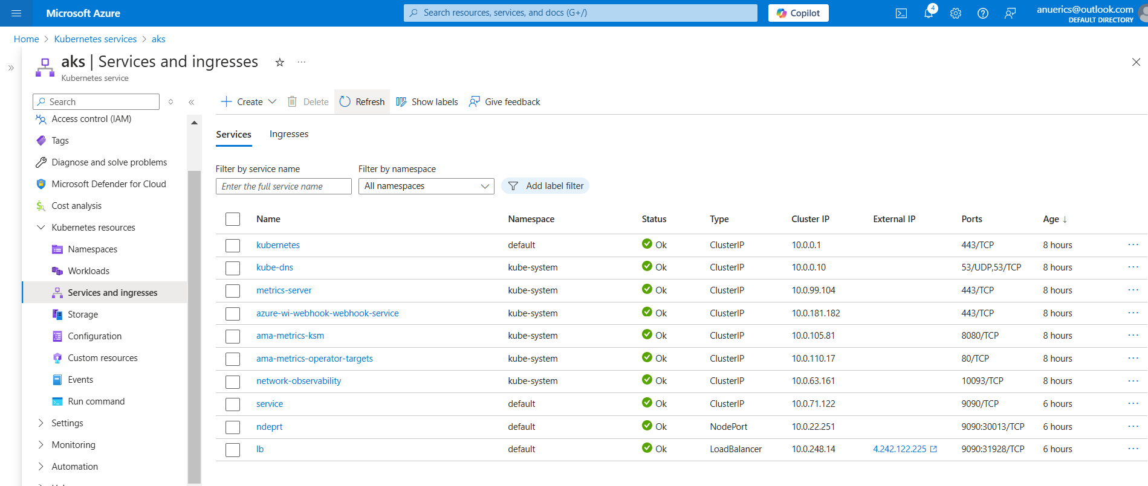

**Date: 23/12/2024 - labels and selectors**